Most popular Machine-to-Machine (M2M) IoT protocols

(http://www.eclipse.org/community/eclipse_newsletter/2014/february/article2.php)
The IoT needs standardized M2M protocols. Two of the most promising for small devices are MQTT and CoAP.
Both MQTT and CoAP:
- Are open standards
- Are better suited to constrained environments than HTTP
- Provide mechanisms for asynchronous communication
- Run on IP
- Have a range of implementations
MQTT gives flexibility in communication patterns and acts purely as a pipe for binary data.
CoAP is designed for interoperability with the web.
- MQTT
MQTT is a publish/subscribe messaging protocol designed for lightweight M2M communications. It was originally developed by IBM and is now an open standard.
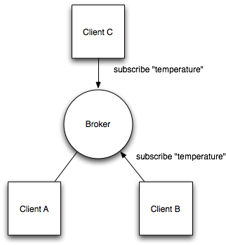

Architecture
MQTT has a client/server model, where every sensor is a client and connects to a server, known as a broker, over TCP.
MQTT is message oriented. Every message is a discrete chunk of data, opaque to the broker.
Every message is published to an address, known as a topic. Clients may subscribe to multiple topics. Every client subscribed to a topic receives every message published to the topic.
For example, imagine a simple network with three clients and a central broker.
All three clients open TCP connections with the broker. Clients B and C subscribe to the topic temperature .
At a later time, Client A publishes a value of 22.5 for topic temperature . The broker forwards the message to all subscribed clients.
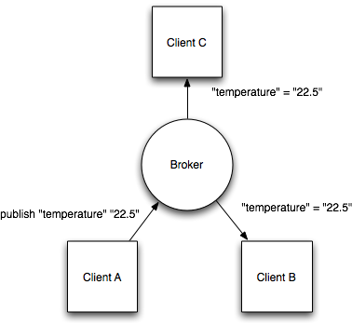
The publisher subscriber model allows MQTT clients to communicate one-to-one, one-to-many and many-to-one.

Topic matching
In MQTT, topics are hierarchical, like a filing system (eg. kitchen/oven/temperature). Wildcards are allowed when registering a subscription (but not when publishing) allowing whole hierarchies to be observed by clients.
The wildcard + matches any single directory name, # matches any number of directories of any name.
For example, the topic kitchen/+/temperature matches kitchen/foo/temperature but not kitchen/foo/bar/temperature
kitchen/# matches kitchen/fridge/compressor/valve1/temperature

Application Level QoS
MQTT supports three quality of service levels, “Fire and forget”, “delivered at least once” and “delivered exactly once”.
QoS 0 - Το πολύ μία φορά (fire and forget): Ένα απλό αίτημα αποστέλλεται χωρίς να περιμένεται απάντηση, αφήνοντας τη διασφάλιση παράδοσης στο TCP.
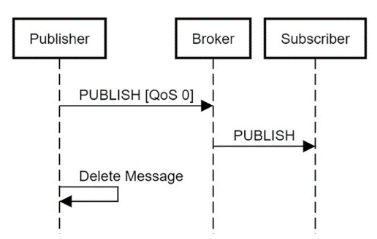
MQTT QoS 0 - το πολύ μία φορά
QoS 1 – Τουλάχιστον μία φορά: Στο QoS επίπεδο 1, το μήνυμα ακολουθείται από απόκριση ACK. Σε περίπτωση απώλειας του ACK, το μήνυμα θα σταλεί ξανά.

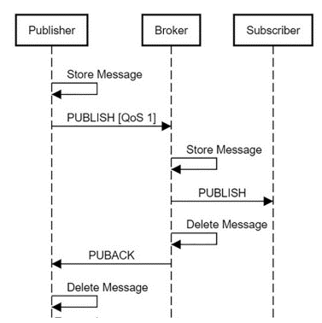
MQTT QoS 1 – Τουλάχιστον μια φορά
QoS 2 - Ακριβώς μια φορά: Στο επίπεδο QoS 2, πρέπει να δημιουργηθεί μια χειραψία τεσσάρων κατευθύνσεων για τη διασφάλιση της παράδοσης μηνυμάτων μόνο μία φορά.
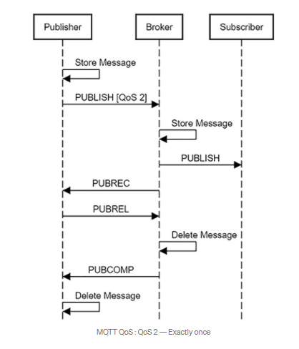
MQTT QoS 2 – Ακριβώς μια φορά

Last Will And Testament
MQTT clients can register a custom “last will and testament” message to be sent by the broker if they disconnect. These messages can be used to signal to subscribers when a device disconnects.

Persistence
MQTT has support for persistent messages stored on the broker. When publishing messages, clients may request that the broker persists the message. Only the most recent persistent message is stored. When a client subscribes to a topic, any persisted message will be sent to the client.
Unlike a message queue, MQTT brokers do not allow persisted messages to back up inside the server.

Security
MQTT brokers may require username and password authentication from clients to connect. To ensure privacy, the TCP connection may be encrypted with SSL/TLS.

MQTT-SN
Even though MQTT is designed to be lightweight, it has two drawbacks for very constrained devices.
Every MQTT client must support TCP and will typically hold a connection open to the broker at all times. For some environments where packet loss is high or computing resources are scarce, this is a problem.
MQTT topic names are often long strings which make them impractical for 802.15.4.
Both of these shortcomings are addressed by the MQTT-SN protocol, which defines a UDP mapping of MQTT and adds broker support for indexing topic names.
Δείτε την παρουσίαση με τίτλο MQTT-SN.pdf στο eclass για περισσότερες λεπτομέρειες.
SMQTT
An extension of MQTT is Secure MQTT (SMQTT) which uses encryption based on lightweight
attribute based encryption. The main advantage of using such encryption is the broadcast
encryption feature, in which one message is encrypted and delivered to multiple other nodes,
which is quite common in IoT applications. In general, the algorithm consists of four main
stages: setup, encryption, publish and decryption. In the setup phase, the subscribers and
publishers register themselves to the broker and get a master secret key according to their
developer’s choice of key generation algorithm. Then, when the data is published, it is encrypted,
published by the broker which sends it to the subscribers and finally decrypted at the subscribers
which have the same master secret key. The key generation and encryption algorithms are not standardized. SMQTT is proposed only to enhance MQTT security feature [Singh15].

- CoAP
CoAP is the Constrained Application Protocol from the CoRE (Constrained Resource Environments) IETF group.

Architecture
Like HTTP, CoAP is a document transfer protocol. Unlike HTTP, CoAP is designed for the needs of constrained devices.
CoAP packets are much smaller than HTTP TCP flows. Bitfields and mappings from strings to integers are used extensively to save space. Packets are simple to generate and can be parsed in place without consuming extra RAM in constrained devices.
CoAP runs over UDP, not TCP. Clients and servers communicate through connectionless datagrams. Retries and reordering are implemented in the application stack. Removing the need for TCP may allow full IP networking in small microcontrollers. CoAP allows UDP broadcast and multicast to be used for addressing.
CoAP follows a client/server model. Clients make requests to servers, servers send back responses. Clients may GET, PUT, POST and DELETE resources.
CoAP is designed to interoperate with HTTP and the RESTful web at large through simple proxies.
Because CoAP is datagram based, it may be used on top of SMS and other packet based communications protocols.

Application Level QoS
Requests and response messages may be marked as “confirmable” or “nonconfirmable”. Confirmable messages must be acknowledged by the receiver with an ack packet.
Nonconfirmable messages are “fire and forget”.

Content Negotiation
Like HTTP, CoAP supports content negotiation. Clients use Accept options to express a preferred representation of a resource and servers reply with a Content-Type option to tell clients what they’re getting. As with HTTP, this allows client and server to evolve independently, adding new representations without affecting each other.
CoAP requests may use query strings in the form ?a=b&c=d . These can be used to provide search, paging and other features to clients.

Security
Because CoAP is built on top of UDP not TCP, SSL/TLS are not available to provide security. DTLS, Datagram Transport Layer Security provides the same assurances as TLS but for transfers of data over UDP. Typically, DTLS capable CoAP devices will support RSA and AES or ECC and AES.

Observe
CoAP extends the HTTP request model with the ability to observe a resource. When the observe flag is set on a CoAP GET request, the server may continue to reply after the initial document has been transferred. This allows servers to stream state changes to clients as they occur. Either end may cancel the observation.

Resource Discovery
CoAP defines a standard mechanism for resource discovery. Servers provide a list of their resources (along with metadata about them) at /.well-known/core. These links are in the application/link-format media type and allow a client to discover what resources are provided and what media types they are.

NAT Issues
In CoAP, a sensor node is typically a server, not a client (though it may be both). The sensor (or actuator) provides resources which can be accessed by clients to read or alter the state of the sensor.
As CoAP sensors are servers, they must be able to receive inbound packets. To function properly behind NAT, a device may first send a request out to the server, as is done in LWM2M, allowing the router to associate the two. Although CoAP does not require IPv6, it is easiest used in IP environments where devices are directly routable.

Comparison
MQTT and CoAP are both useful as IoT protocols, but have fundamental differences.
MQTT is a many-to-many communication protocol for passing messages between multiple clients through a central broker. It decouples producer and consumer by letting clients publish and having the broker decide where to route and copy messages. While MQTT has some support for persistence, it does best as a communications bus for live data.
CoAP is, primarily, a one-to-one protocol for transferring state information between client and server. While it has support for observing resources, CoAP is best suited to a state transfer model, not purely event based.
MQTT clients make a long-lived outgoing TCP connection to a broker. This usually presents no problem for devices behind NAT. CoAP clients and servers both send and receive UDP packets. In NAT environments, tunnelling or port forwarding can be used to allow CoAP, or devices may first initiate a connection to the head-end as in LWM2M.
MQTT provides no support for labelling messages with types or other metadata to help clients understand it. MQTT messages can be used for any purpose, but all clients must know the message formats up-front to allow communication. CoAP, conversely, provides inbuilt support for content negotiation and discovery allowing devices to probe each other to find ways of exchanging data.
Both protocols have pros and cons. Choosing the right one depends on your application.
- LWM2M
Δείτε την παρουσίαση με τίτλο lwm2mfinal-160105195649.pdf στο eclass.

- AMQP
The Advanced Message Queuing Protocol (AMQP) is another session layer protocol that was
designed for financial industry. It runs over TCP and provides a publish/ subscribe architecture
which is similar to that of MQTT. The difference is that the broker is divided into two main components: exchange and queues, as shown in Figure 6. The exchange is responsible for receiving publisher messages and distributing them to queues based on pre-defined roles and conditions. Queues basically represent the topics and subscribed by subscribers which will get the sensory data whenever they are available in the queue.
Figure 6: AMQP Architecture

- XMPP
Extensible Messaging and Presence Protocol (XMPP) is a messaging protocol that was designed
originally for chatting and message exchange applications. It was standardized by IETF more than a decade ago. Hence, it is well known and has proven to be highly efficient over the internet. Recently, it has been reused for IoT applications as well as a protocol for SDN. This reusing of the same standard is due to its use of XML which makes it easily extensible. XMPP supports both publish/ subscribe and request/ response architecture and it is up to the application developer to choose which architecture to use. It is designed for near real-time applications and, thus, efficiently supports low-latency small messages. It does not provide any quality of service guarantees and, hence, is not practical for M2M communications. Moreover, XML messages create additional overhead due to lots of headers and tag formats which increase the power consumption that is critical for IoT application. Hence, XMPP is rarely used in IoT but has gained some interest for enhancing its architecture in order to support IoT applications.

